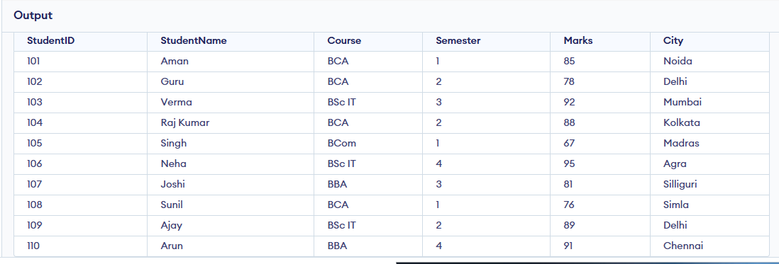
SELECT * FROM Student;

SELECT * FROM Student WHERE Marks > 80;
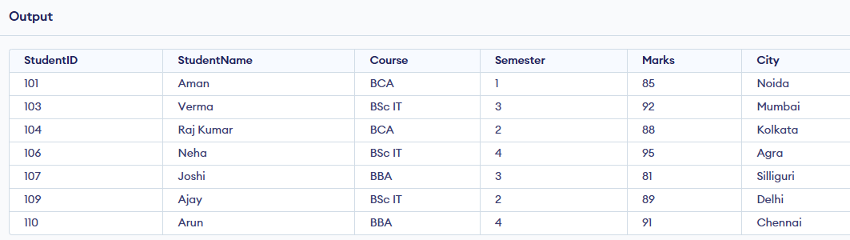
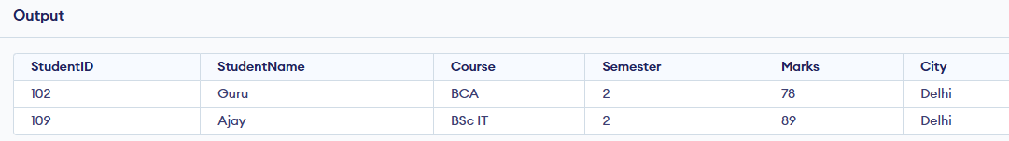
SELECT * FROM Student WHERE City = 'Delhi';

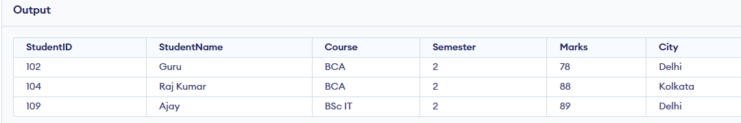
SELECT * FROM Student WHERE Semester = 2;


